**EDUCONNECT LEARNING CENTRE**

1.INTRODUCTION

* 1. Overview

Education learning center, an educational institution, Zoho books to effectively manage their financial processes, maintain accurate records, and make informed financial decisions.

1.2 Purpose

Using an education institution in zoho books or any accounting software can serve several purposes and help you achieve various financial and operational goals.

**2.Problem Definition & Design Thinking**

2.1 Empathy map

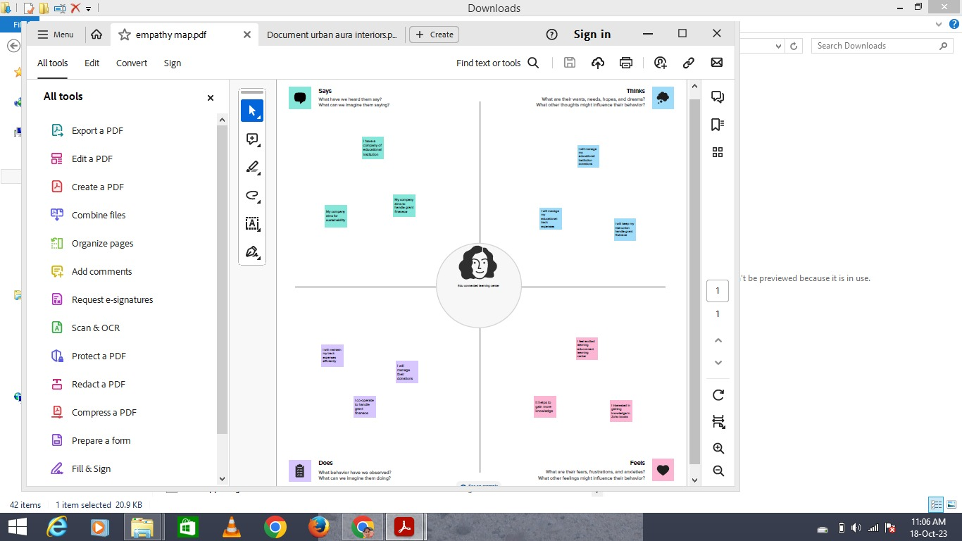

**2.2 Ideation & Brainstorming Map**

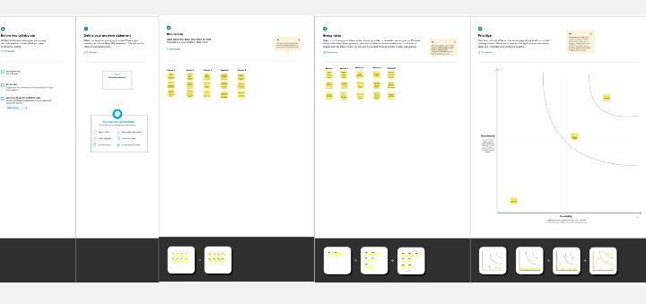

**3 Result**

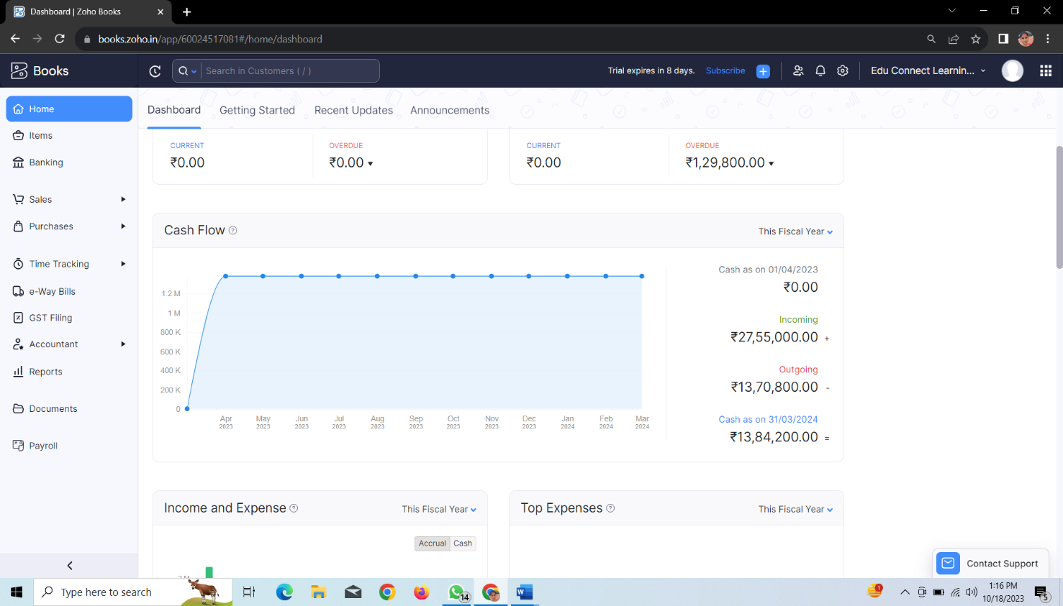

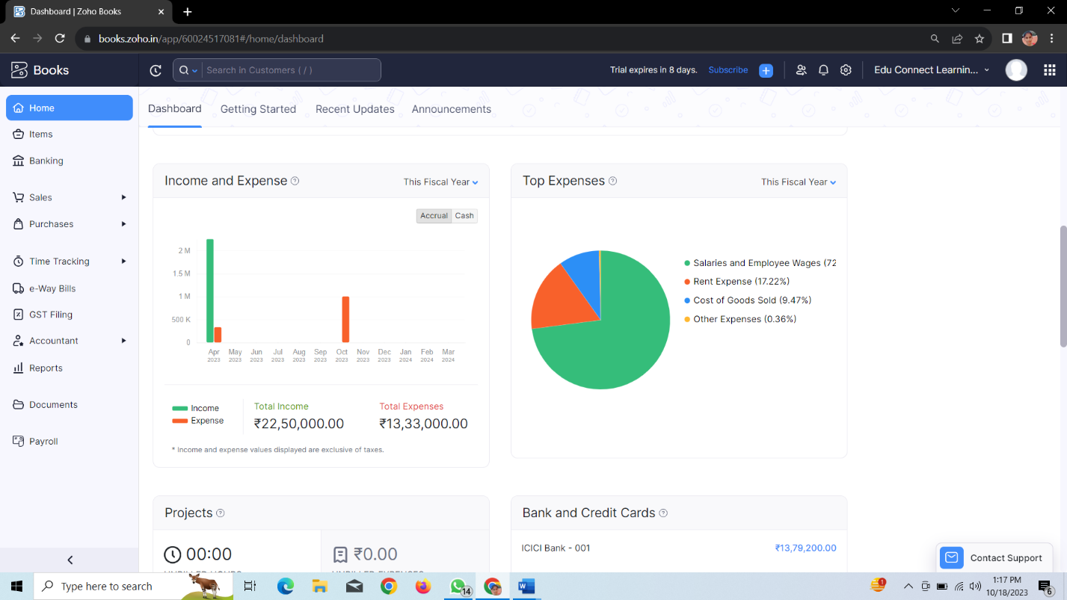

**4 Advantages and Disadvantages**

**Advantages**

1. Financial management: * accurate records: zoho books helps maintain accurate financial records, which is crucial for interior design companies to track project expenses and profitability
2. Invoices and Payment tracking: * professional Invoices: it allows for the creation of professional invoices, helping to ensure timely payments from clients

**Disadvantages**

1)Learning curve: * zoho books may have learning curve for users unfamiliar with accounting software, which could require training or onboarding

2)cost: * while zoho books offers various pricing plans, there is a cost associate with its use, which may be a disadvantage for small business with tight budgets

**5 Applications**

The interior design company solution using zoho books can be applied in various arears within the company operations. here are some key arears where this solution can be beneficial

**6 Conclusion**

In conclusion, the field of interior design is a multifaceted and dynamic profession that combines artistic creativity with practical functionality to transform living and working spaces.

**7 Future Scope**

* Sustainable and Eco-Friendly Design: Sustainability will continue to be a driving force in interior design.
* Biophilic Design: Integrating nature into interior spaces will become more prevalent.